Aggregation

1. What is aggregation?
   * An Aggregation is a particular kind of connection between two classes.
   * Aggregation(HAS-A relationship): parent can exist without child and a child can exist independently of the parent and this involve a one-to-one, one-to-many, or many-to-many relationship between the participating objects.
2. 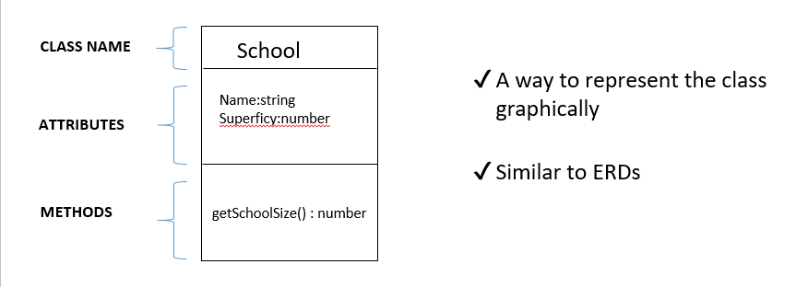What is a UML class diagram ?